**AICTE Activity Point Programme Report**

Submitted in Partial Fulfilment for the Award of Degree of

Bachelor of Engineering

in

Electronic and Communication Engineering

Submitted by

Sourav S Shetty

1NT21EC149

**Under the guidance of**

Dr. Viswanatha V

Associate professor

Dr. Raghunatha Reddy M V

Assistant professor



**2024-2025**

**AICTE Activity Point Programme CERTIFICATE**

This is to certify that the AICTE Activity Point Programme has been successfully carried out by Sourav S Shetty bearing USN 1NT21EC149, Bonafide student of **Nitte Meenakshi Institute of Technology** in partial fulfilment of the requirements for the award of degree of **(Branch name)** of **Visvesvaraya Technological University**, **Belagavi** during **20204-2025**. It is certified that all corrections/suggestions indicated for Internal Assessment have been incorporated in the report. The AICTE Activity Point Programme report has been approved as it satisfies the academic requirements in respect of AICTE Activity Point Programme for the said degree.

…………… …………… …….……

Signature Signature Signature

Name of Faculty Incharge Name of Department HOD Dr. Karunakara Rai

/ Dr. Deepika K M

**CERTIFICATE PHOTOCOPY**

Issued by NGO/Organization

**DECLARATION**

I, Sourav S Shetty bearing the USN:1NT21EC149, student of Bachelor of Engineering, **(Branch name), Nitte Meenakshi Institute of Technology, Bengaluru,** hereby declare that the **AICTE Activity Point Programme** work has been carried out by me under the supervision and guidance of **Department Staff Coordinator** submitted by me as a partial fulfilment for the award of Bachelor of Engineering degree in **(Branch Name)** from **Visvesvaraya Technological University, Belagavi** during **2024-2025.**

I hereby declared that the AICTE activity point work has been carried out at following partner organizations:

1. GRAMA VIKASA

**Signature**

Name: Sourav S Shetty

USN:1NT21EC149

**ACKNOWLEDGEMENT**

**I extend my heartfelt gratitude to Dr. H C Nagaraj, Principal of Nitte Meenakshi Institute of Technology; Dr. Visvanatha V and Dr. Raghunatha Reddy M V, Professors at Nitte Meenakshi Institute of Technology, Bengaluru; and Dr. Karunakara Rai, AICTE Activity Points Coordinator at Nitte Meenakshi Institute of Technology, for their unwavering support and provision of essential resources for the successful execution of this program.**

**I am also deeply thankful to Grama Vikasa for their invaluable support in offering meaningful volunteering opportunities and resources.**

**Lastly, I would like to express my sincere appreciation and respect to my parents, the teaching and non-teaching staff of the Department, and all my friends who have supported me, directly or indirectly, throughout my AICTE Activity Point Programme journey.**

**Student Name: Sourav S Shetty**

**USN number: 1NT21EC149**

**ACTIVITY SUMMARY**

|  |  |  |  |  |
| --- | --- | --- | --- | --- |
| **Si. No.** | **Activity Heads** | **From date**  **–**  **To date** | **Number of Days** | **Total Number of Hours** |
| **1.** | **Community Interaction & Cultural Program** | **03/05/2025** | **1** | **6** |
| **2.** | **Garden Visit and Plant Study** | **03/05/2025** | **1** | **5** |
| **3.** | **Farming Activities (Cotton, Cashew, etc.)** | **04/05/2025** | **1** | **4** |
| **4.** | **Hybrid Seed Farm Interaction & Assistance** | **04/05/2025** | **1** | **8** |
| **5.** | **Dairy Farm Visit (Milking Process)** | **05/05/2025** | **1** | **5** |
| **6.** | **Temple Visit & Cultural Understanding** | **06/05/2025** | **1** | **6** |
| **7.** | **Final Reflection & Feedback with Coordinators** | **06/05/2025** | **1** | **3** |

**Rubrics for Activity Points**

|  |  |  |  |  |  |  |  |  |
| --- | --- | --- | --- | --- | --- | --- | --- | --- |
|  | **Very Good**  **(8-10)** | **Good**  **(6-7)** | **Average**  **(5)** | **Activity-1** | **Activity-2** | **Activity-3** | **Activity-4** | **Activity-5** |
| **Need Analysis** | Thoroughly identified and understood specific community needs. | Identified and addressed most key community needs | Identified some needs but lacked comprehensive analysis. |  |  |  |  |  |
| **Implementation** | Executed effectively with exceptional efficiency and impact. | Implemented well with minor improvements possible. | Implemented partially with noticeable gaps in execution. |  |  |  |  |  |
| **Community Involvement** | Engaged community fully with outstanding collaboration efforts. | Involved community well with some collaboration gaps. | Engaged community minimally with limited collaboration efforts. |  |  |  |  |  |
| **Impact Measurement** | Thoroughly measured impact with clear, measurable outcomes. | Measured impact with clear outcomes, though incomplete. | Measured impact partially with limited data or analysis. |  |  |  |  |  |
| **Total** | | | |  |  |  |  |  |
| **Grand Total** | | | | | | | |  |

**ABSTRACT**

The AICTE Activity Point Programme, under the initiative titled "Grama Vikasa," offered a transformative rural immersion experience from May 3rd to May 6th, 2025, at Hirihabbe village in Chitradurga. This four-day program was designed to provide engineering students with an understanding of rural life, farming practices, and the integration of sustainable technologies in agriculture. As part of this program, we engaged in various hands-on activities including farming, cultural exchange, temple visits, and interaction with local communities. The experience provided not only technical learning but also emotional and social development, fostering a deep appreciation for rural livelihoods and sustainable living.

Throughout the program, we experienced a close connection with the lifestyle of villagers. The visit started with a warm welcome from local coordinators followed by a guided tour through a community garden featuring a wide variety of trees such as arecanut, coconut, mango, apple, and sandalwood. These visits introduced us to the importance of plant diversity in local ecosystems and the long-term economic value of forestry. In the subsequent days, we engaged directly in farming activities, interacting with local farmers who shared insights about cultivating cotton, pomegranate, cashew, and hybrid seeds. These discussions opened our eyes to the techniques, challenges, and innovations used in real-world agriculture.

In addition to farming, we also explored the cultural and spiritual dimensions of village life. Visits to historical temples and participation in local rituals allowed us to understand the deep connection between tradition and community. The final day concluded with an educational visit to a dairy farm where we observed the milking process and learned about rural dairy practices. Altogether, the Grama Vikasa program was not just an academic requirement but a life-changing experience that broadened our perspective, deepened our empathy, and strengthened our commitment to contribute meaningfully to rural development through engineering knowledge and social responsibility.

**CONTENTS**

1. **CHAPTER 1**

INTRODUCTION (Brief introduction about all the activities head carried out) ………………………………… ……………..

1. **CHAPTER 2**

Details of activities (ACTIVITY HEAD- 1)

2.1. Overview ………………………………………………….

2.2. Use of Technology (if any) …………………………………………

2.3. Sustainable Development best practices ………………………

(ACTIVITY HEAD- 2)

2.1. Overview ………………………………………………….

2.2. Use of Technology (if any) …………………………………………

2.3. Sustainable Development best practices ………………………

**3.CHAPTER 3 (overall learnings)**

3.1. Innovative approaches taken

3.2. Research done

3.3. Knowledge and Understanding gained

3.4. Professional Values and best practices incorporated

3.5. Areas for further development

3.6. Challenges and solutions

3.7. Feedback and continuous improvement

**4. CHAPTER 4**

Documentation of Activities (includes Jio tag Photographs/ testimonials if any) …………………….

**5. CHAPTER 5**

**Conclusion**

**REFERENCE**

**CHAPTER 1: INTRODUCTION**

The Grama Vikasa program is a rural development initiative designed under the AICTE Activity Points Scheme to promote social responsibility, practical learning, and the application of engineering knowledge in real-world settings. Our program was held in Hirihabbe, a serene village in the Chitradurga district of Karnataka. The objective was to expose students to the rural way of life and understand the socio-economic, cultural, and technological aspects of village communities.

On Day 1, we reached the village and were welcomed by local coordinators. The interaction helped us understand the structure and functioning of the village. A visit to a community garden introduced us to sustainable agricultural practices. In the evening, children from the village organized a delightful cultural event featuring local dance and music, offering us a glimpse into their rich traditions.

The next three days were dedicated to practical exposure. We worked on farming lands alongside local farmers, planting seeds, watering crops, and clearing fields. This activity helped us understand the strenuous efforts that go into food production. We also visited local temples, learning about their architecture and cultural relevance. Furthermore, we explored how technology—such as solar-powered water pumps and mobile apps for crop management—is being integrated into rural farming practices, empowering the agricultural community.

This immersive experience deepened our appreciation for rural development, sustainable agriculture, and the value of cultural heritage, aligning with the AICTE's goal of holistic engineering education through community engagement

**CHAPTER 2: DETAILS OF ACTIVITIES**

**ACTIVITY HEAD – 1: Community Interaction and Cultural Exchange**

**2.1 Overview:**  
The first day was largely focused on familiarizing ourselves with the village and establishing a rapport with the locals. We were greeted by coordinators and local leaders who shared the village’s history, development initiatives, and daily challenges. A guided tour of the village included a visit to a flourishing garden maintained by the community. This space served not only as a source of nutrition but also as a symbol of collective responsibility.

Later that evening, a cultural event was held by the village children. The performance featured folk songs, dance forms like Dollu Kunitha, and storytelling sessions in the local dialect. The energy and creativity displayed by the children were truly inspiring. It emphasized the importance of preserving cultural roots even amidst modernization. We also participated in the event, singing and exchanging knowledge about urban lifestyle and education, building mutual understanding and respect.

**2.2 Use of Technology:**  
Though Day 1 was primarily cultural, discussions with coordinators revealed that mobile apps were used to schedule farming operations and monitor crop health. They also showed us how messaging platforms are used to coordinate village-wide events, highlighting the penetration of digital tools even in remote areas.

**2.3 Sustainable Development Best Practices:**  
The community garden followed organic farming practices, utilizing compost and natural pesticides. Watering schedules were based on seasonal rainfall patterns, and children were educated on ecological practices. This approach reflects the core principles of sustainability—environmental responsibility, resource conservation, and community awareness.

**ACTIVITY HEAD – 2: Farming and Temple Visits**

**2.1 Overview:**  
From Day 2 to Day 4, we actively engaged in agricultural activities. Each morning began

with visits to farms where we assisted in tasks such as soil tilling, weeding, watering, and sowing. The process was physically demanding but intellectually enriching. Farmers shared insights into crop cycles, pest management, and the impact of climate change on yield. We observed how labor-intensive and weather-dependent the process is, which increased our respect for the farming community.

In addition to farming, we visited temples that serve as cultural and spiritual centers in the village. Temples such as the Veerabhadra Swamy temple not only represent architectural heritage but also function as hubs for festivals and communal decisions. These visits broadened our understanding of how religion, tradition, and community are deeply interwoven in rural life.

**2.2 Use of Technology:**  
We were introduced to simple yet effective innovations like drip irrigation systems, mobile-based weather forecast tools, and solar water pumps. These tools were instrumental in reducing labor and conserving water, proving that even low-cost technology can drive rural transformation.

**2.3 Sustainable Development Best Practices:**  
Crop rotation, composting, and minimal use of chemical fertilizers were some practices we observed. The villagers employed techniques that maintained soil fertility and reduced erosion. Water conservation was a priority—most farms used borewells with solar-powered pumps, and plastic mulch was used in some areas to reduce water evaporation.

**CHAPTER 3: OVERALL LEARNINGS**

3.1 Innovative Approaches Taken:  
Our team adapted quickly to the rural environment and took initiative in assisting farming tasks, setting up temporary irrigation channels, and organizing group activities for local children. We also suggested the idea of using weather alert apps more actively for better planning.

3.2 Research Done:  
We investigated how solar energy and organic farming are interrelated and how mobile technology is aiding agriculture. We compared traditional and modern farming practices and their impact on yield and sustainability.

3.3 Knowledge and Understanding Gained:  
The experience taught us the dynamics of rural ecosystems, including interdependence among villagers, the economic cycle of farming, and the societal role of temples and festivals. We also gained technical knowledge about basic irrigation systems and eco-friendly farming.

3.4 Professional Values and Best Practices Incorporated:  
Teamwork, time management, empathy, and respect for different cultures were the primary values gained. It strengthened our resolve to work toward inclusive development in our careers as engineers.

3.5 Areas for Further Development:  
We realized the need for more effective technological training for farmers, mobile network improvements, and better waste management systems in rural areas.

3.6 Challenges and Solutions:  
Language barriers and physical fatigue were initial hurdles. However, through teamwork and local assistance, we overcame them. Breaking down communication with gestures and learning basic Kannada terms proved helpful.

3.7 Feedback and Continuous Improvement:  
We received positive feedback from coordinators for our active participation. We also proposed a follow-up digital workshop for the villagers to introduce them to simple mobile apps for farming and weather forecasting.

**4. CHAPTER 4 :Documentation of Activities**

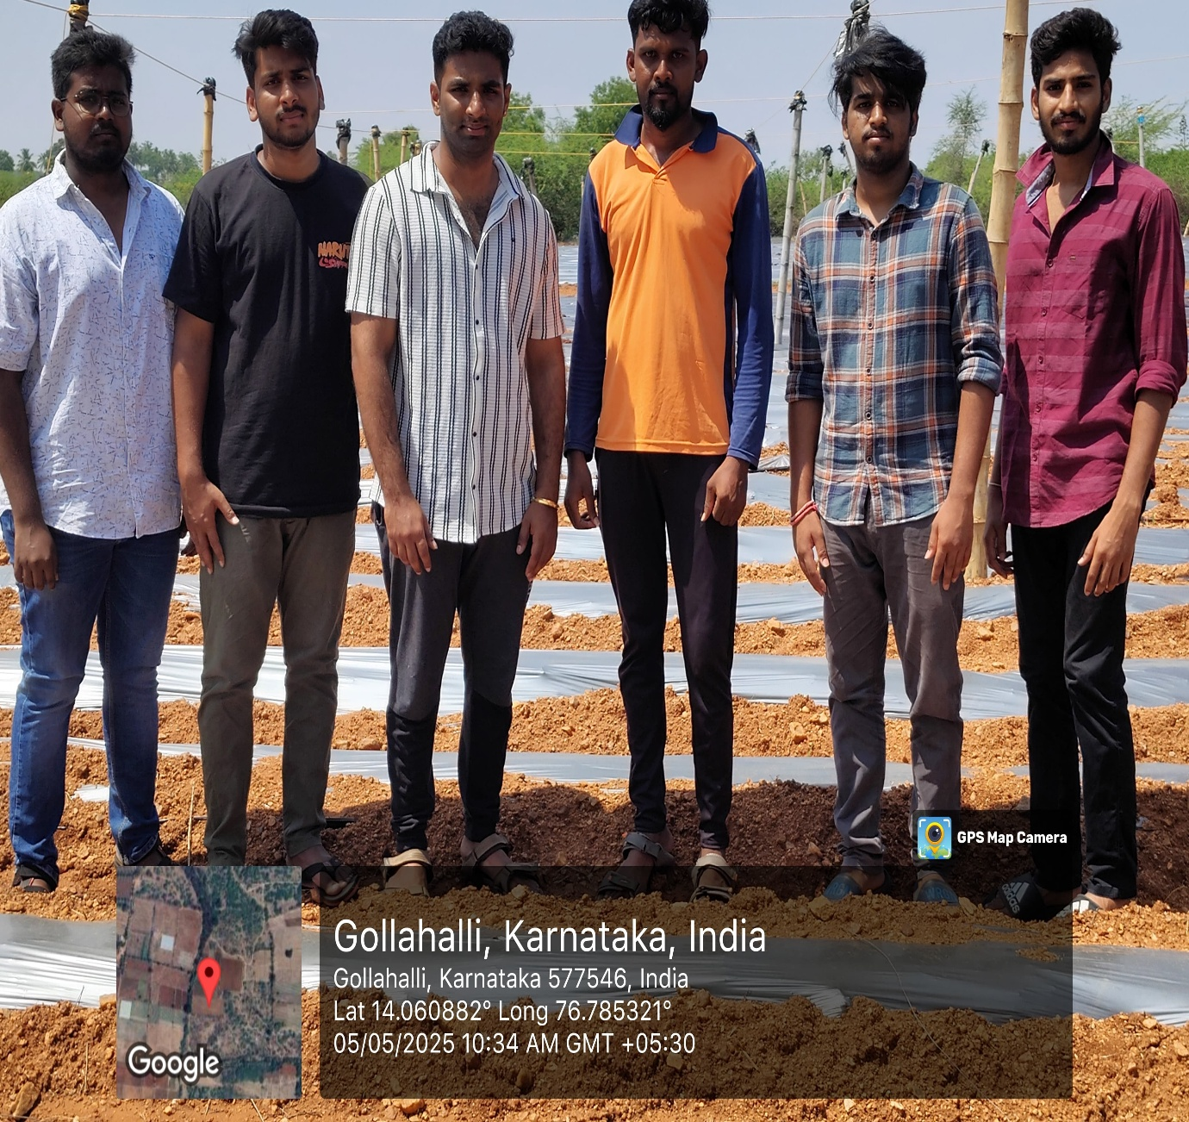

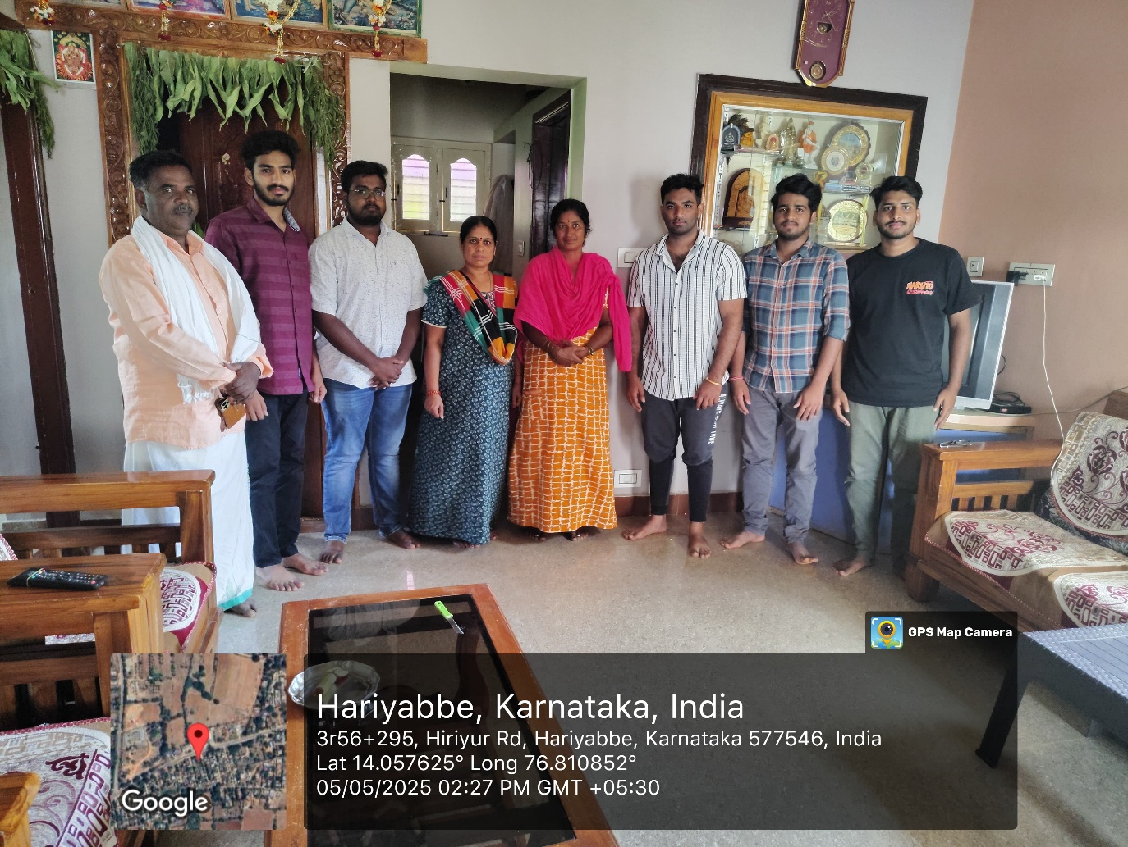

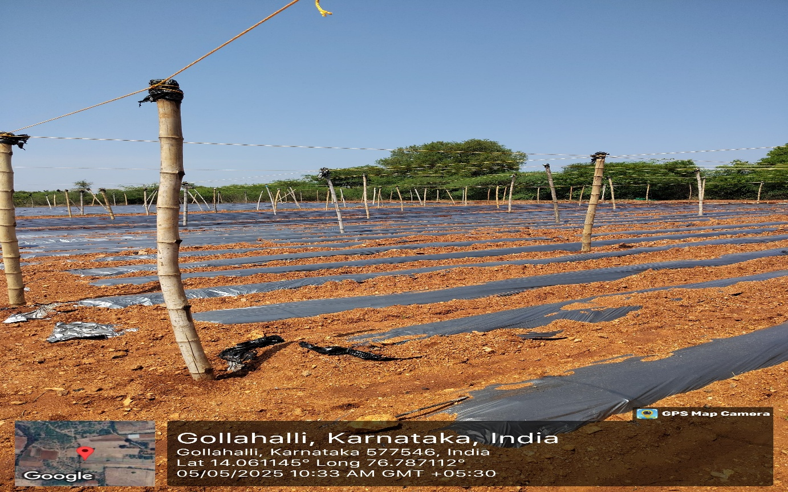

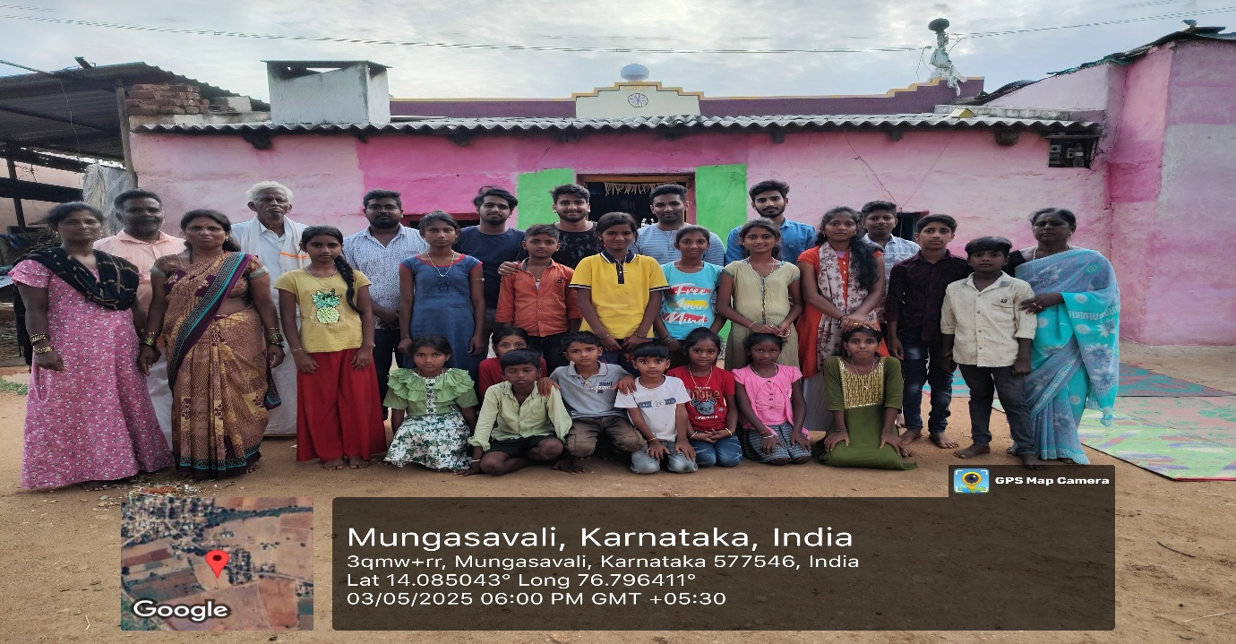

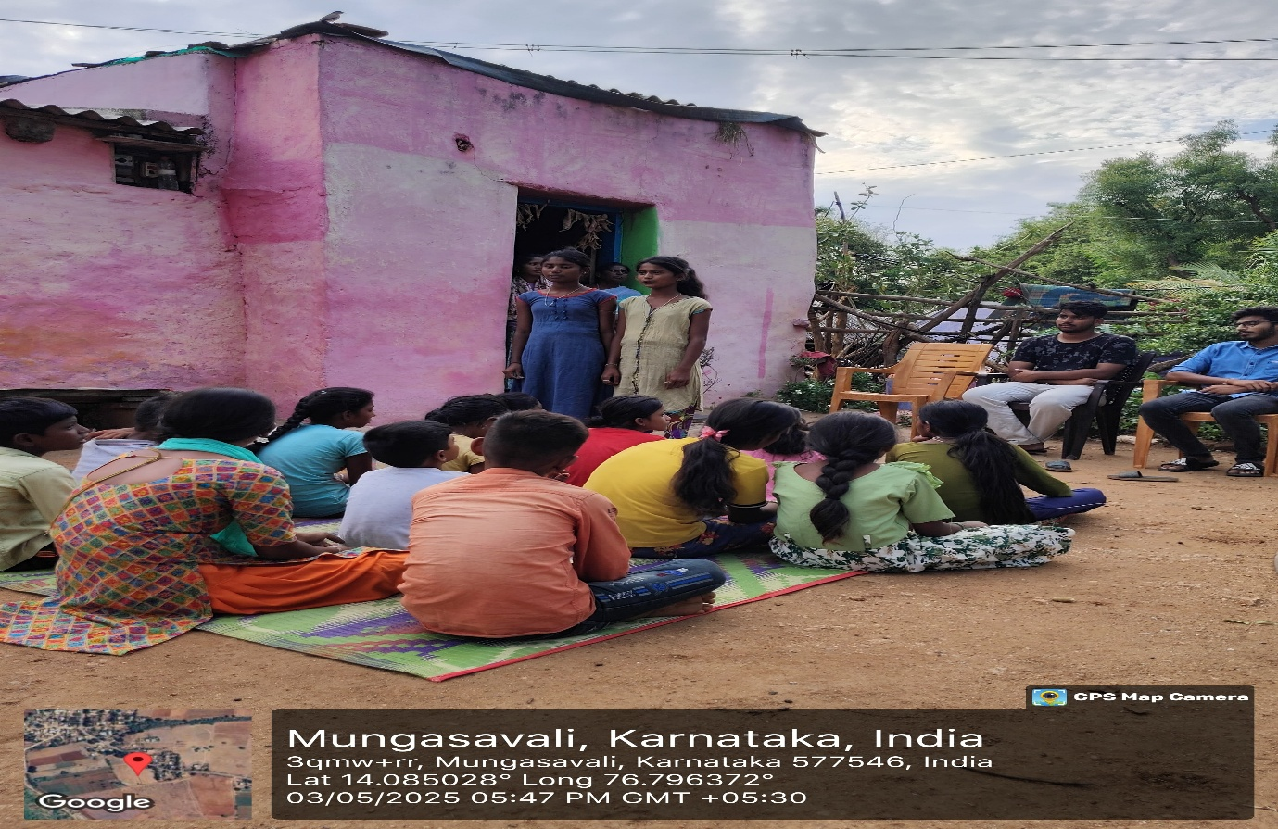

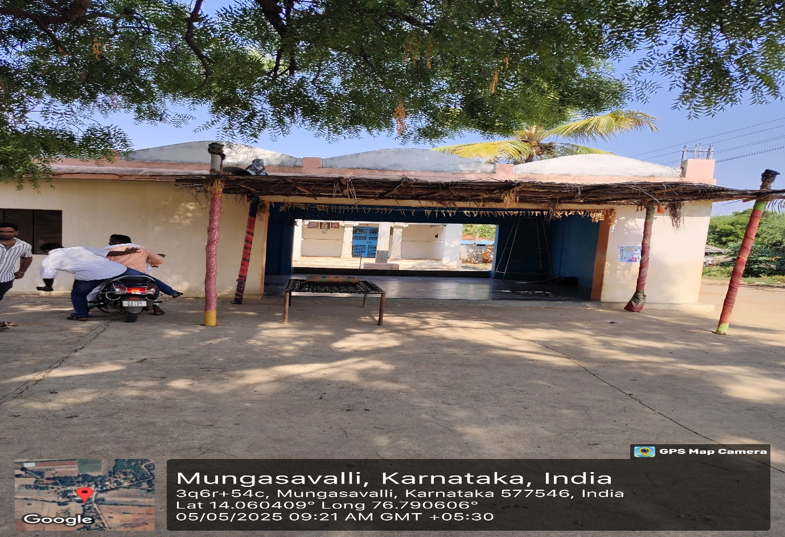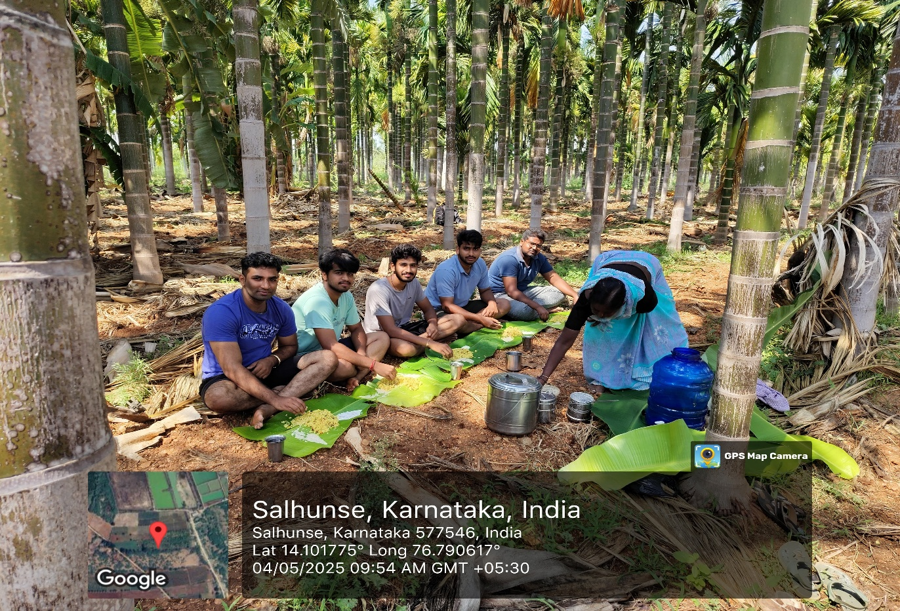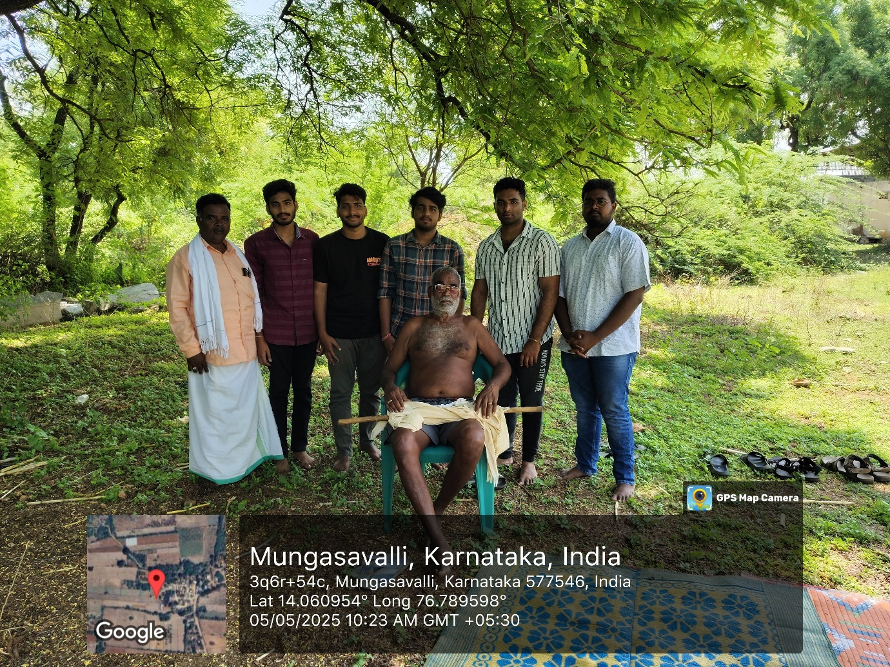

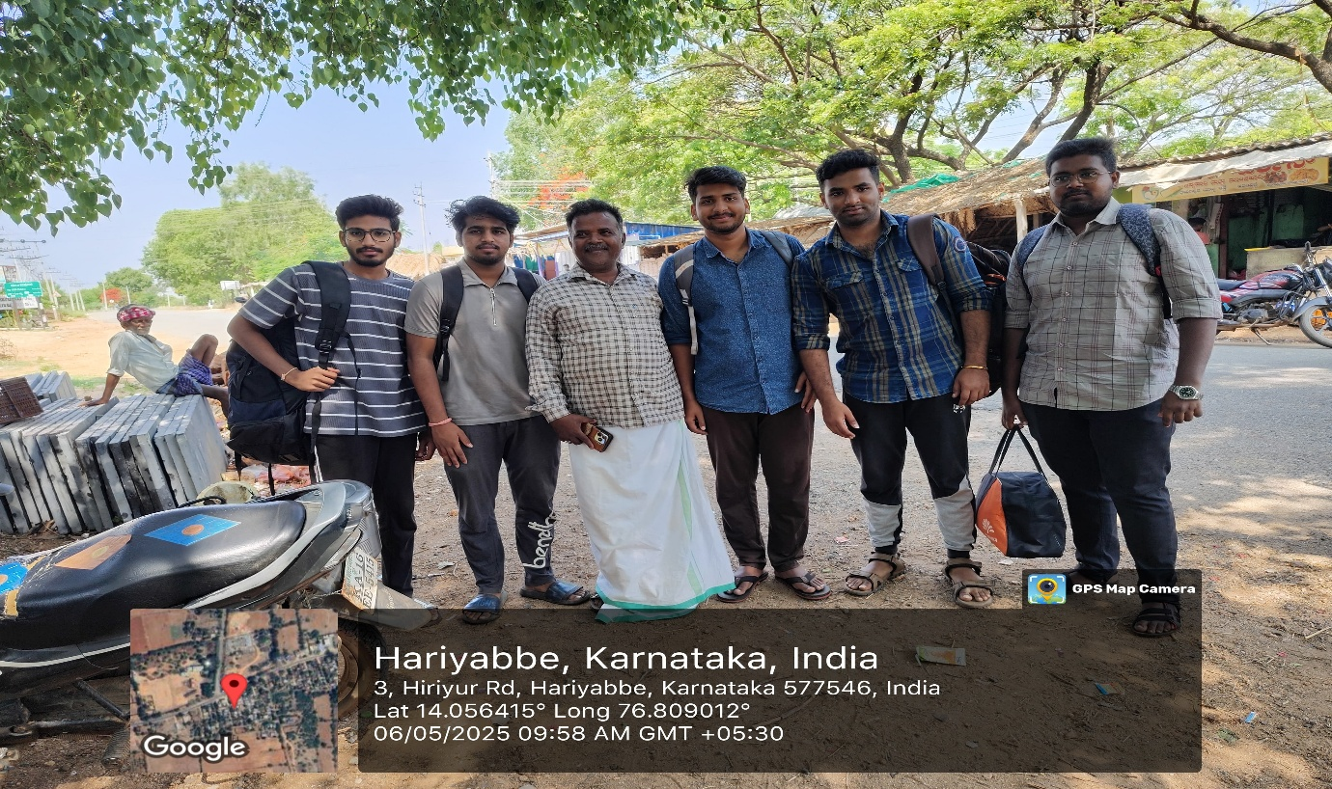

**CHAPTER 5: CONCLUSION**

The Grama Vikasa program was a transformative journey that bridged classroom learning with ground reality. Our time in Hirihabbe village provided us with invaluable insights into rural life, sustainable agriculture, and the power of community. It deepened our understanding of how engineering and technology can positively impact rural development. Through hands-on farming and cultural exchange, we cultivated a sense of responsibility, adaptability, and social commitment. The experience will remain a cornerstone in our educational journey, guiding our future endeavors to make a meaningful impact on society.

The AICTE Activity Point Programme undertaken in collaboration with Grama Vikasa NGO provided a transformative learning experience rooted in rural engagement, agricultural sustainability, and cultural immersion. This four-day initiative not only exposed us to the challenges and rhythms of village life but also allowed us to meaningfully contribute to the community through physical labor, respectful participation, and shared learning.

We witnessed the critical role of grassroots efforts in food production, water conservation, and animal husbandry — all vital components of rural resilience. From weed removal and crop salvage to understanding the significance of small dams and temple spaces, each experience enriched our perspective as future engineers and responsible citizens.

Our time spent in Bheemana Bande and Hale Yalanadu villages reinforced the idea that development must be inclusive, sustainable, and empathetic. We leave this programme with

a renewed sense of purpose and a commitment to applying our skills toward real-world problems — especially those rooted in the heart of our nation’s villages.

Key Takeaways:

1.Learning by Doing: We developed a deep appreciation for agricultural and livestock practices by engaging in them directly.

2.Community Connection: Villagers welcomed us warmly and offered invaluable insights into their livelihoods and challenges.

3. 3. 3.Cultural Awareness: Temple visits and time spent with local families helped us better understand rural traditions and values.

4Team Dynamics: Tasks like weed clearing and mango collection required coordination, patience, and endurance — strengthening our teamwork.

5.Sustainable Insights: Low-tech, eco-friendly solutions practiced in the villages illustrated how sustainability can be achieved without complexity.

Looking Forward:

While this experience was impactful, it has opened several avenues for continued engagement and future improvements:

1.Scalability: Encouraging more students across disciplines to participate in similar village immersion programs would amplify impact.

2.Sustainability Education: Introducing technology sensitization workshops could help villagers adopt simple tech tools without undermining traditional practices.

3.Documentation and Knowledge Sharing: Creating digital documentation, including photos, videos, and short reflections, can help future batches learn from our journey.

4.Long-Term Collaboration: Institutions can explore partnerships with NGOs like Grama Vikasa for long-term development projects —

5.including water management, sustainable agriculture, and community education.

ACKNOWLEDGMENTS

I would like to express my deepest gratitude to all those who made this rural immersion initiative possible.

1.Grama Vikasa NGO – For their continuous support and belief in the importance of rural development and agricultural sustainability. Their coordination, hospitality, and field-level guidance were instrumental in ensuring the success of this programme.

2.Farmers and Village Community Members – Without their openness, cooperation, and participation, the experience would not have been as meaningful. Their willingness to share their knowledge and involve us in their daily lives greatly enriched our learning.

3.Faculty Coordinators and Department Staff – For their encouragement, mentorship, and efforts in organizing and guiding us throughout the AICTE Activity Point Programme.

4.Local Leaders and Village Coordinators – For facilitating our visits to farms, check dams, temples, and cultural landmarks, allowing us to experience the socio-environmental ecosystem of the villages first-hand.

5.My Teammates – For their collaboration, teamwork, and shared commitment during all activities, which made the journey productive and enjoyable.

Lastly, I am personally grateful for the opportunity to participate in this programme. The experience not only allowed me to contribute to the rural community but also provided valuable insights into grassroots engagement, traditional sustainability practices, and the importance of community-driven development.